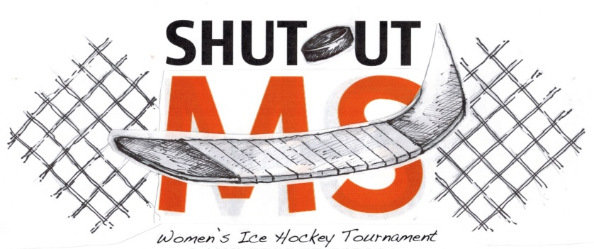
November 13-15, 2015
OFFICIAL REGISTRATION FORM

December 9-11, 2022
saratogastormhockey.weebly.com

Welcome to the 10th Annual Shut-Out MS Tournament, hosted by the Saratoga Storm! Last year we raised $4,500 and we are looking to beat it this year. We are looking forward to a fun-filled and hockey-filled weekend!

Our tournament is being held to help raise awareness of Multiple Sclerosis, an unpredictable, often disabling disease of the central nervous system that disrupts the flow of information within the brain, and between the brain and body. MS is thought to affect more than 2.3 million people worldwide. MS is more common (at least 2-3 times) in women than in men.

Tournament Structure:
- Tournament will be held the weekend of December 9-11 in Weibel and Vernon rinks in Saratoga Springs, NY.
- 4 teams per division. Spots will be filled on a first come - first served basis. $500 deposit will save your spot.
- Each team is guaranteed 3 games. Two teams in each division will have a 4th game.
- USA Hockey sanctioned tournament (teams need to be USA hockey registered)
- Each team is asked to bring a basket to raffle which represents the area they are from.

Tournament Fee:
- Team Entry Fee is $900.00.
- Make checks payable to: Saratoga Storm and mail to: 5 Doggett’s Coat Place, Saratoga Springs, NY 12866
- Venmo: @Reisha-Rieder (518-368-9255)
- PayPal: rrieder@albany.edu (will come up as Saratoga Storm)

Team Information:

TEAM NAME:
TOURNAMENT DIVISION (CHECK ONE): REC D B/C
TEAM CONTACT INFORMATION:
Contact Name:
Address:

City: State:
Zip Code:

Phone# (C): Email:
Secondary Contact Name: Phone# C:

